Important points

1. One common example is the List returned by [Arrays.asList()](http://download.oracle.com/javase/6/docs/api/java/util/Arrays.html" \l "asList%28T...%29): it is documented **not** to support any structural modification (i.e. removing or adding elements) (emphasis mine):

Returns a **fixed-size** list backed by the specified array.

1. Ms🡺 non static inner class cannot have static methods🡺
2. To add not null constraint after creating a table🡺alter table tablename modify colname datatype(size) not null;
3. what is the difference between where and having clause🡺

The **HAVING clause** was added to SQL because the WHERE keyword could not be used with aggregate functions. The**difference between** the two is in the relationship to the GROUP BY **clause**: WHERE comes before GROUP BY; SQL evaluates the WHERE **clause** before it groups records.

1. Subquery reduces performance
2. Query to find out a particular column is referenced in which and all tables

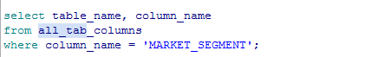

1. If there are no pointers in Java, then why do we get NullPointerException? 🡺In Java, the pointer equivalent is Object reference
2. 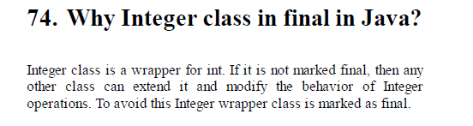

Doubts and Pending works

1. Find out few datatypes that used in your app db tables
2. Is composite key and EmbeddedId concept is same?
3. What is Candidate key and alternate key

**106. What are the different types of References in Java?**

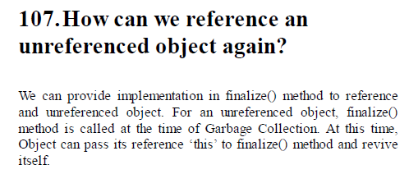

**170. How will you copy elements from a Source List to another list?**



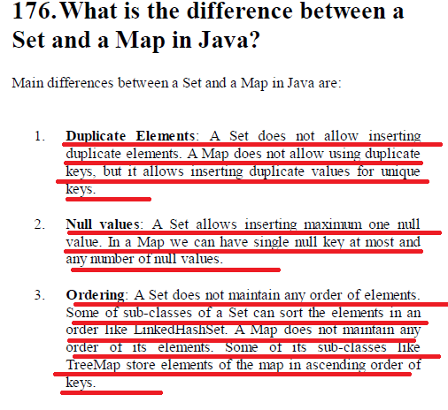

**185. What are the Hash Collision resolution techniques?**

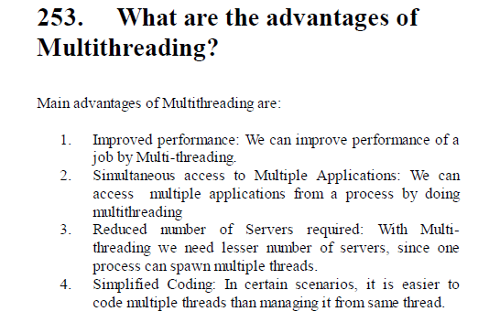

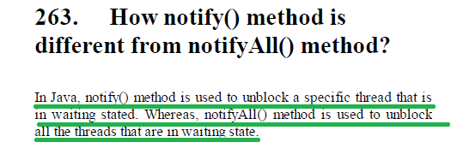

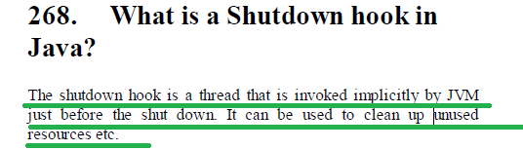

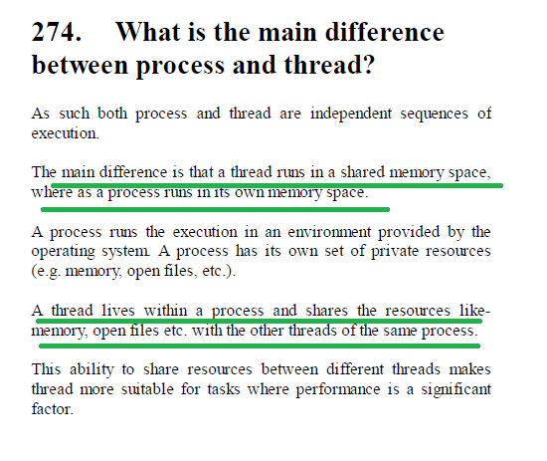

In general, the purpose of Interrupt is to ask current thread to stop its current execution and finish unexpectedly.

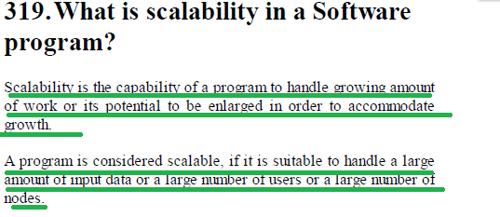

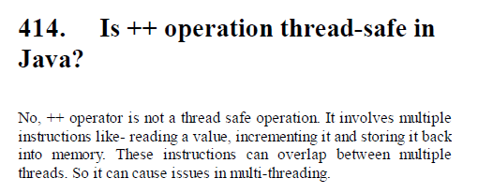

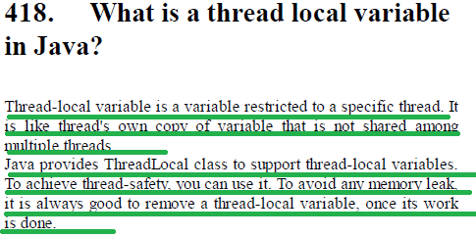

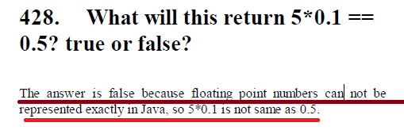

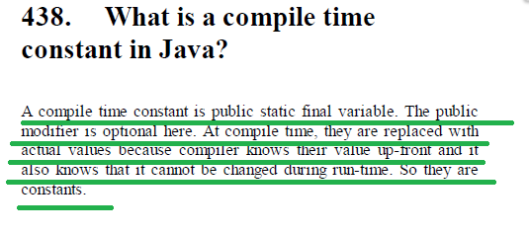

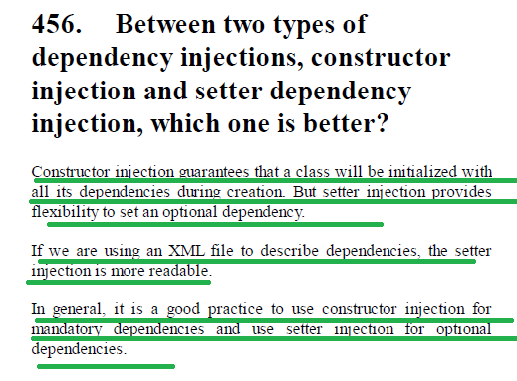

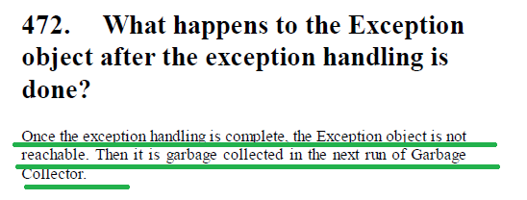

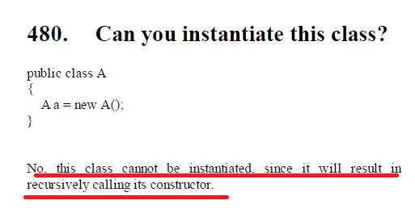

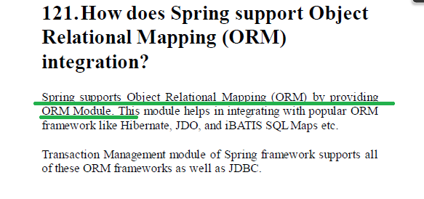

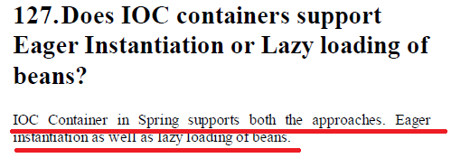

**What is Bean wiring in Spring? 🡺 I think its same as autowiring 🡺**

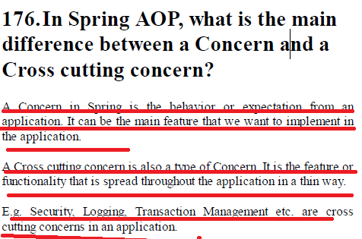

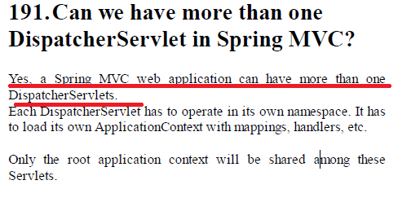

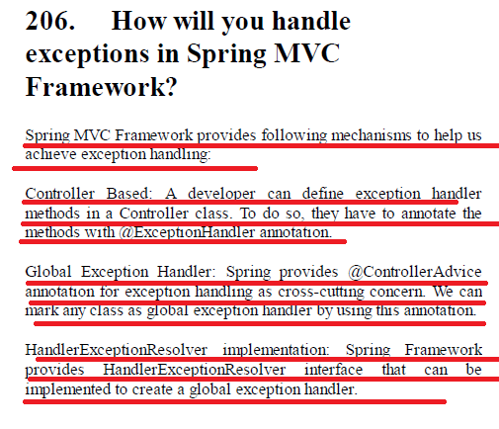

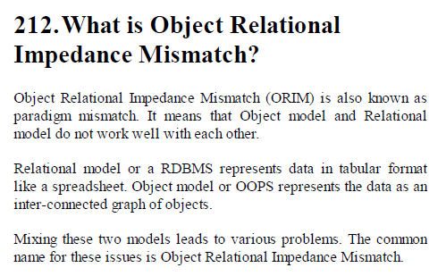

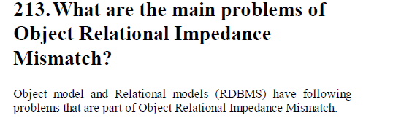

1. 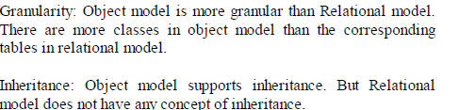
2. 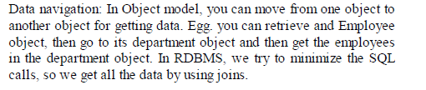

**How will you call a stored procedure in Hibernate?**

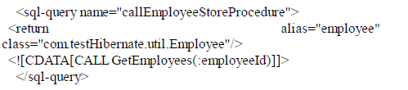

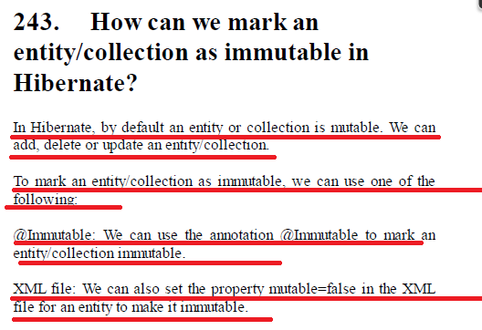

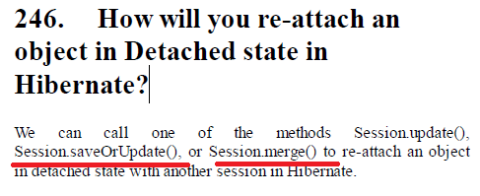

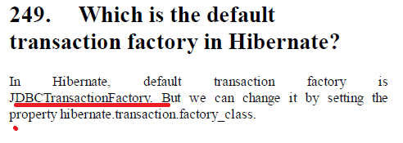

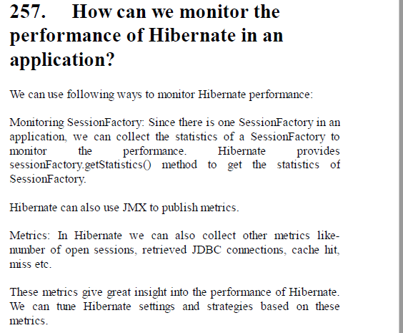

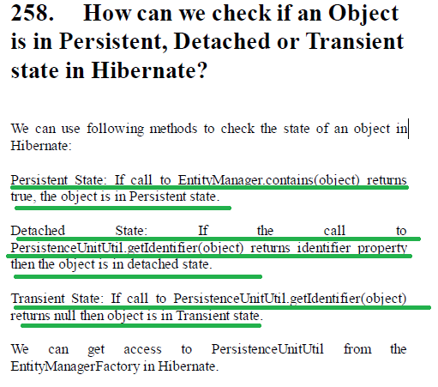

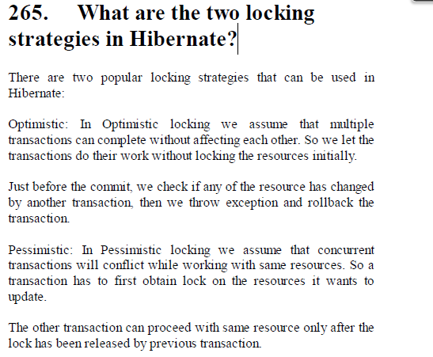

Material Design Interview Questions

1. **What Is Angular Material?**

Angular Material is a UI component library for Angular JS developers. Angular Material's reusable UI components helps in constructing attractive, consistent, and

functional web pages and web apps while adhering to modern web design principles like browser portability, device independence, and graceful degradation.

1. **How To Use Angular Material?**

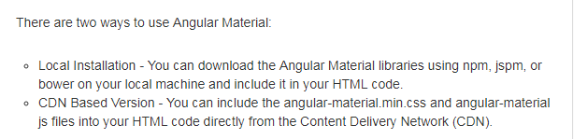

1. 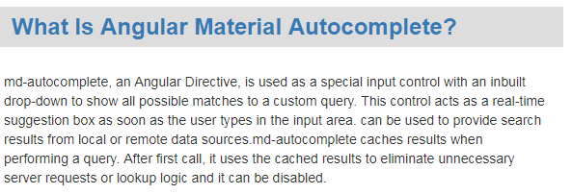

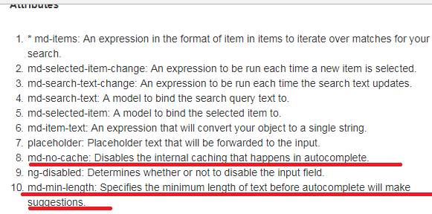

1. 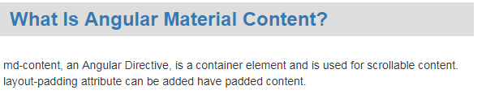
2. 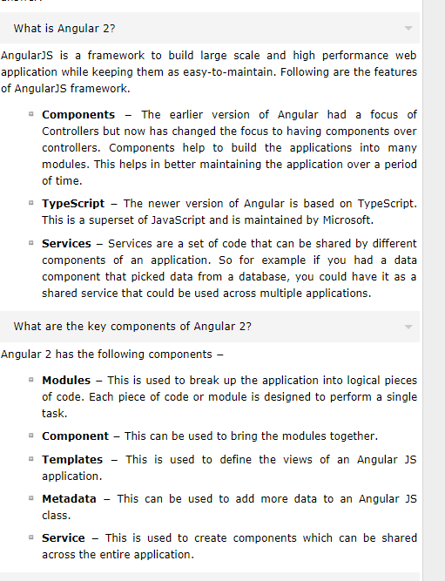
3. 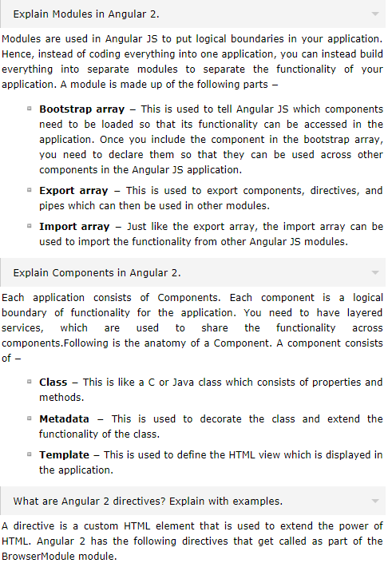
4. 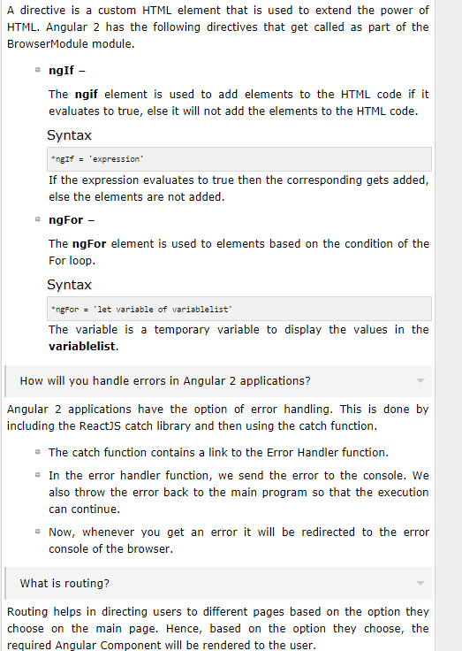
5. 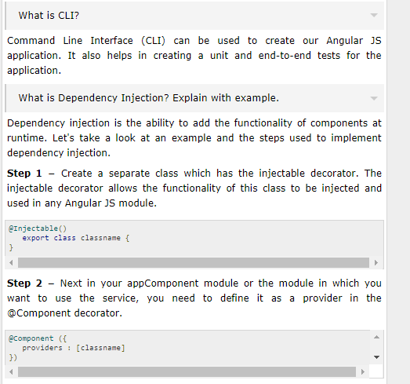
6. 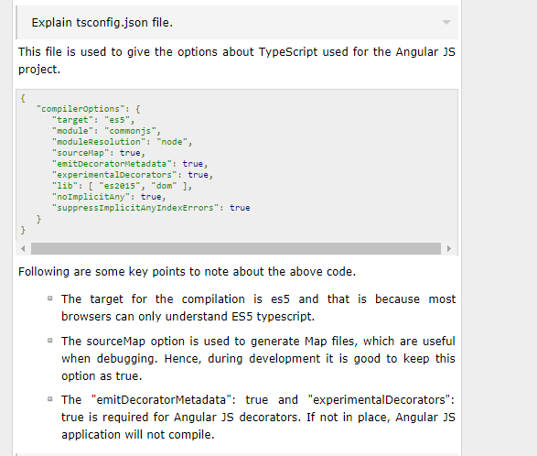
7. 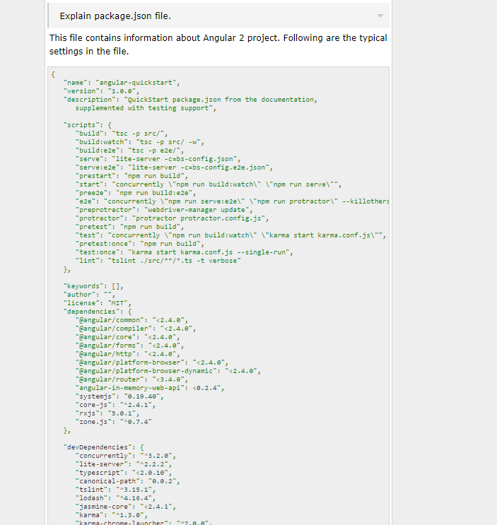

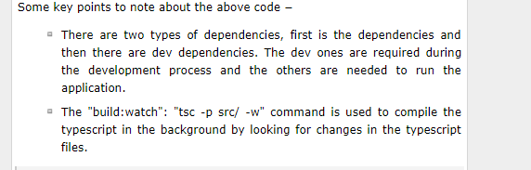

1. 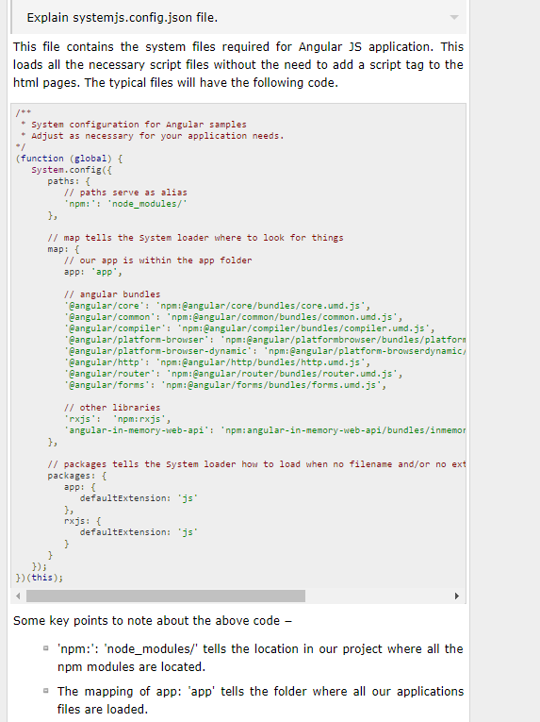
2. Explain app.module.ts file.
3. How will you convert an input to all lowercase?
4. How will you convert an input to all uppercase?
5. How will you get a substring from a string

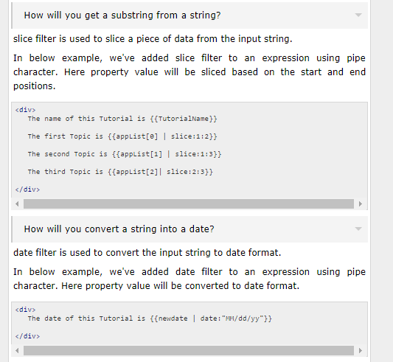

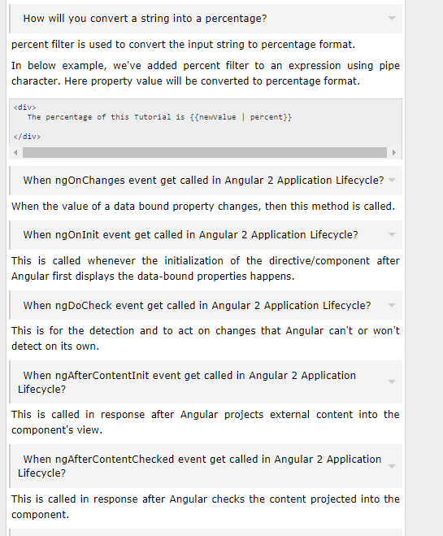

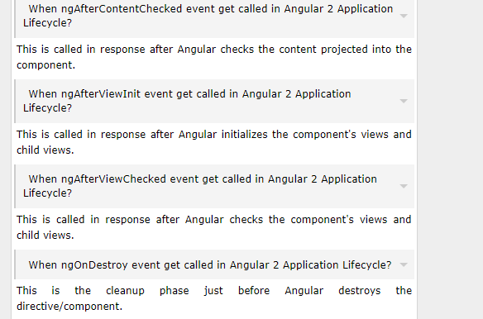

Angular interview Questions from

<https://www.codeproject.com/Articles/1169073/Angular-Interview-Questions>

1. Explain the life cycle hooks of Angular 2 application
2. 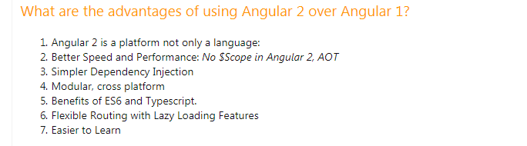
3. 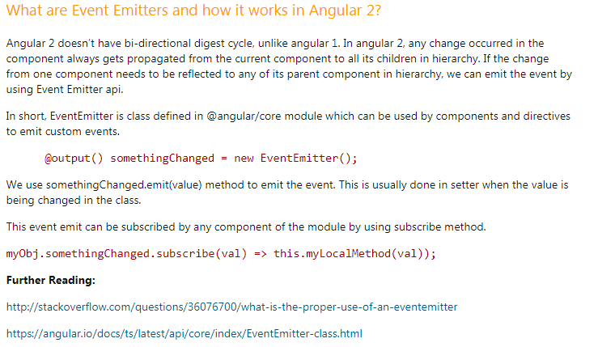
4. 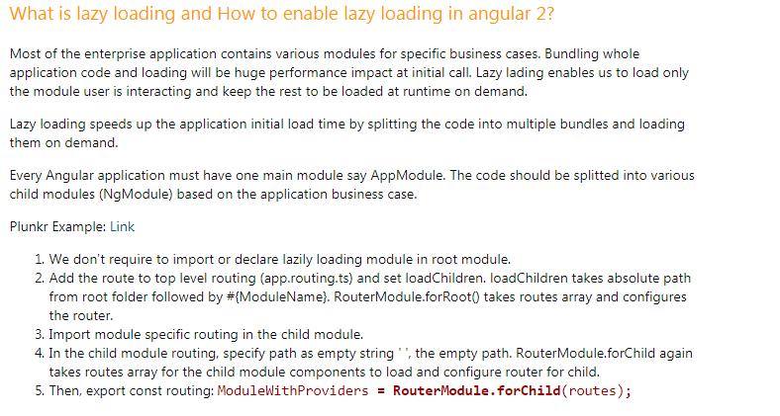
5. 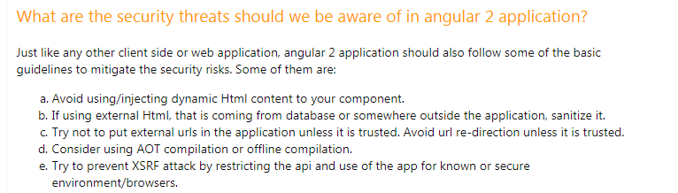

### How would you optimize the angular 2 application for better performance?

1. 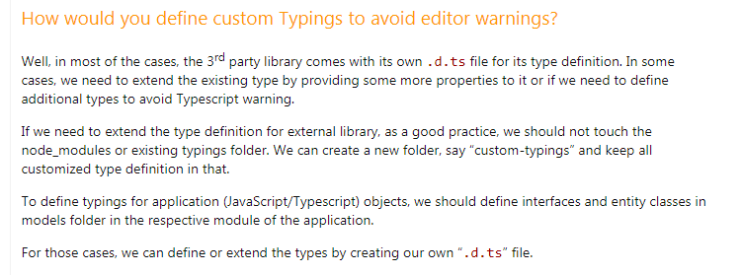
2. 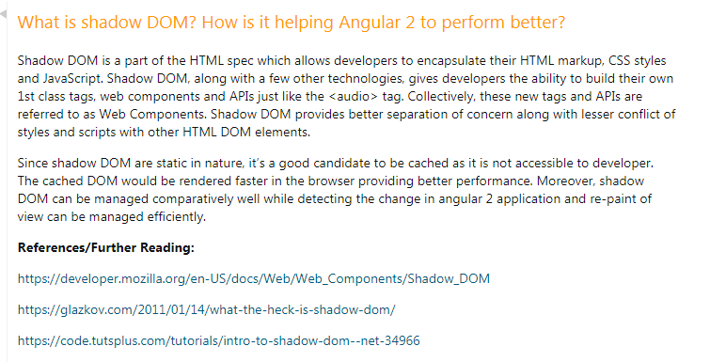
3. 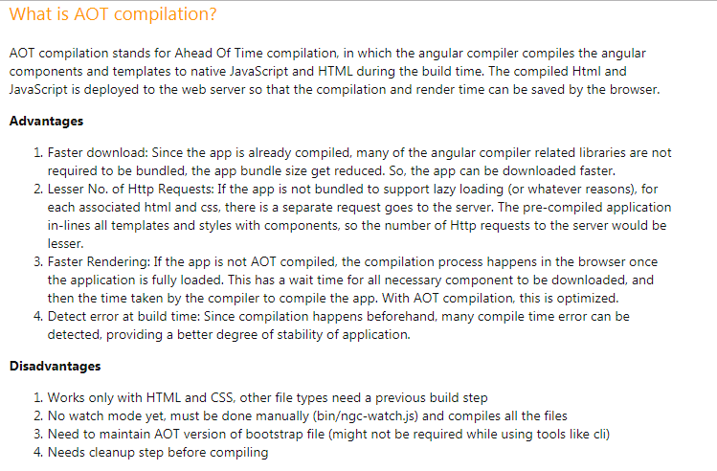
4. 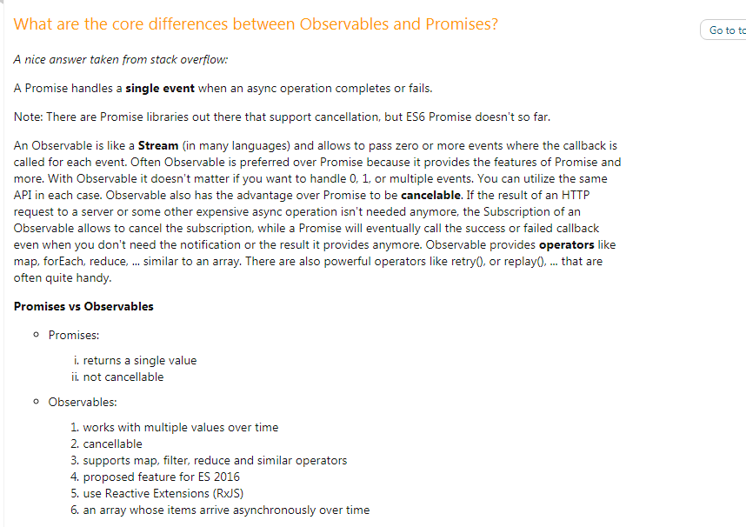
5. 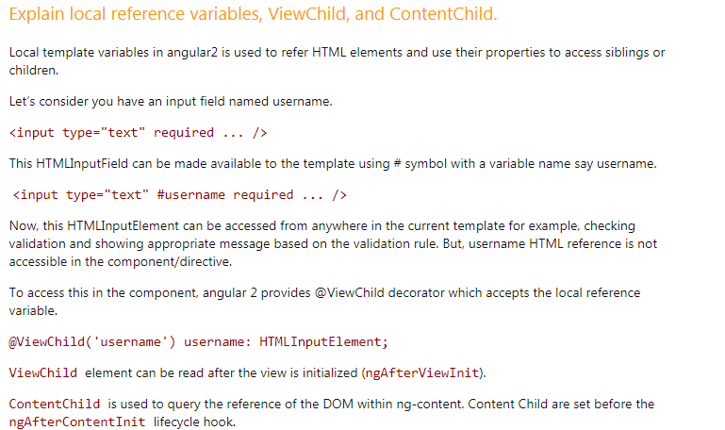

Example 🡺

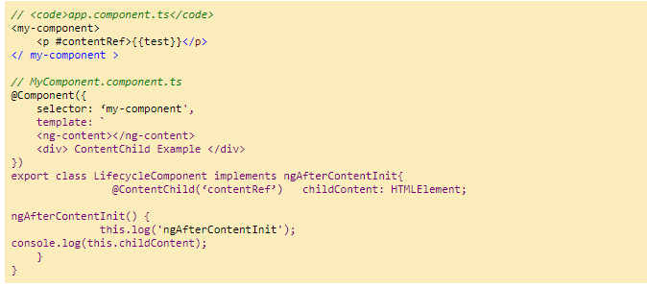

1. 